Online Supermarket Management System
Aim: To create a cloud-based Online Supermarket Management System using Zoho Creator to manage customer details, product orders, quantities, and item classification
Procedure:
- Log in to Zoho Creator and create a new application.
- Create a form named Customer Order Details.
- Add fields such as Customer Name, Address, Phone, Email, Item Name, Item Category, Quantity, Price, and Total Amount.
- Create an Item Classification form with Item ID, Item Name, Category, Price, Stock Quantity, and Availability.
- Enter customer and product details, calculate the total amount, and save the records.
Implementation
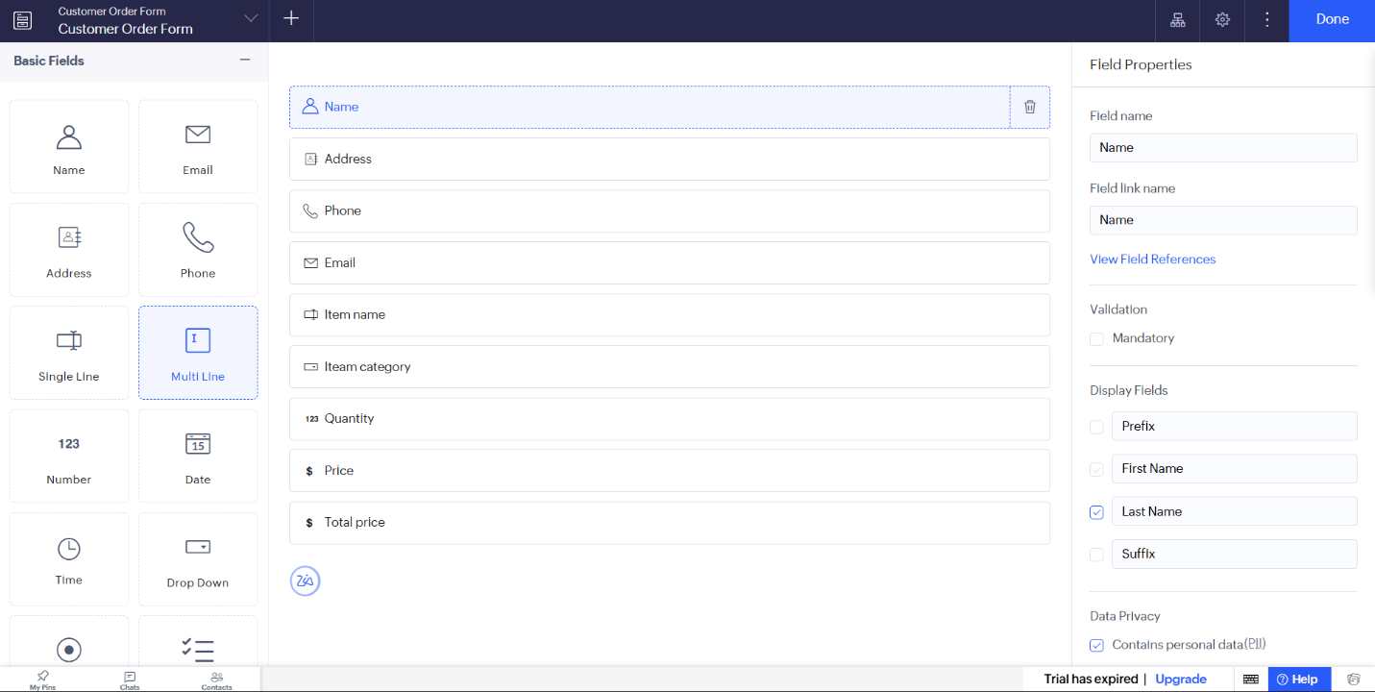

Result
Result: Thus, a cloud-based Online Supermarket Management System was created successfully to manage customer orders, product categories, prices, and stock availability.

